Alexander Baldree
04/02/26
Module 2.2 Assignment
CSD420

Git Hub Link:
https://github.com/Panda-Alex21687/CSD420

Correctly installed JavaFX:
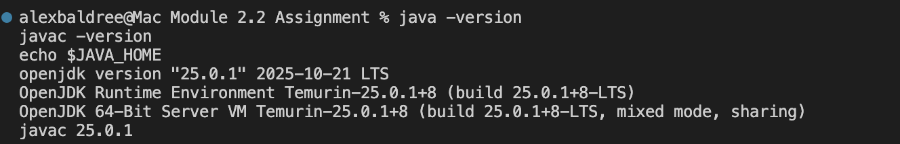

Run program:
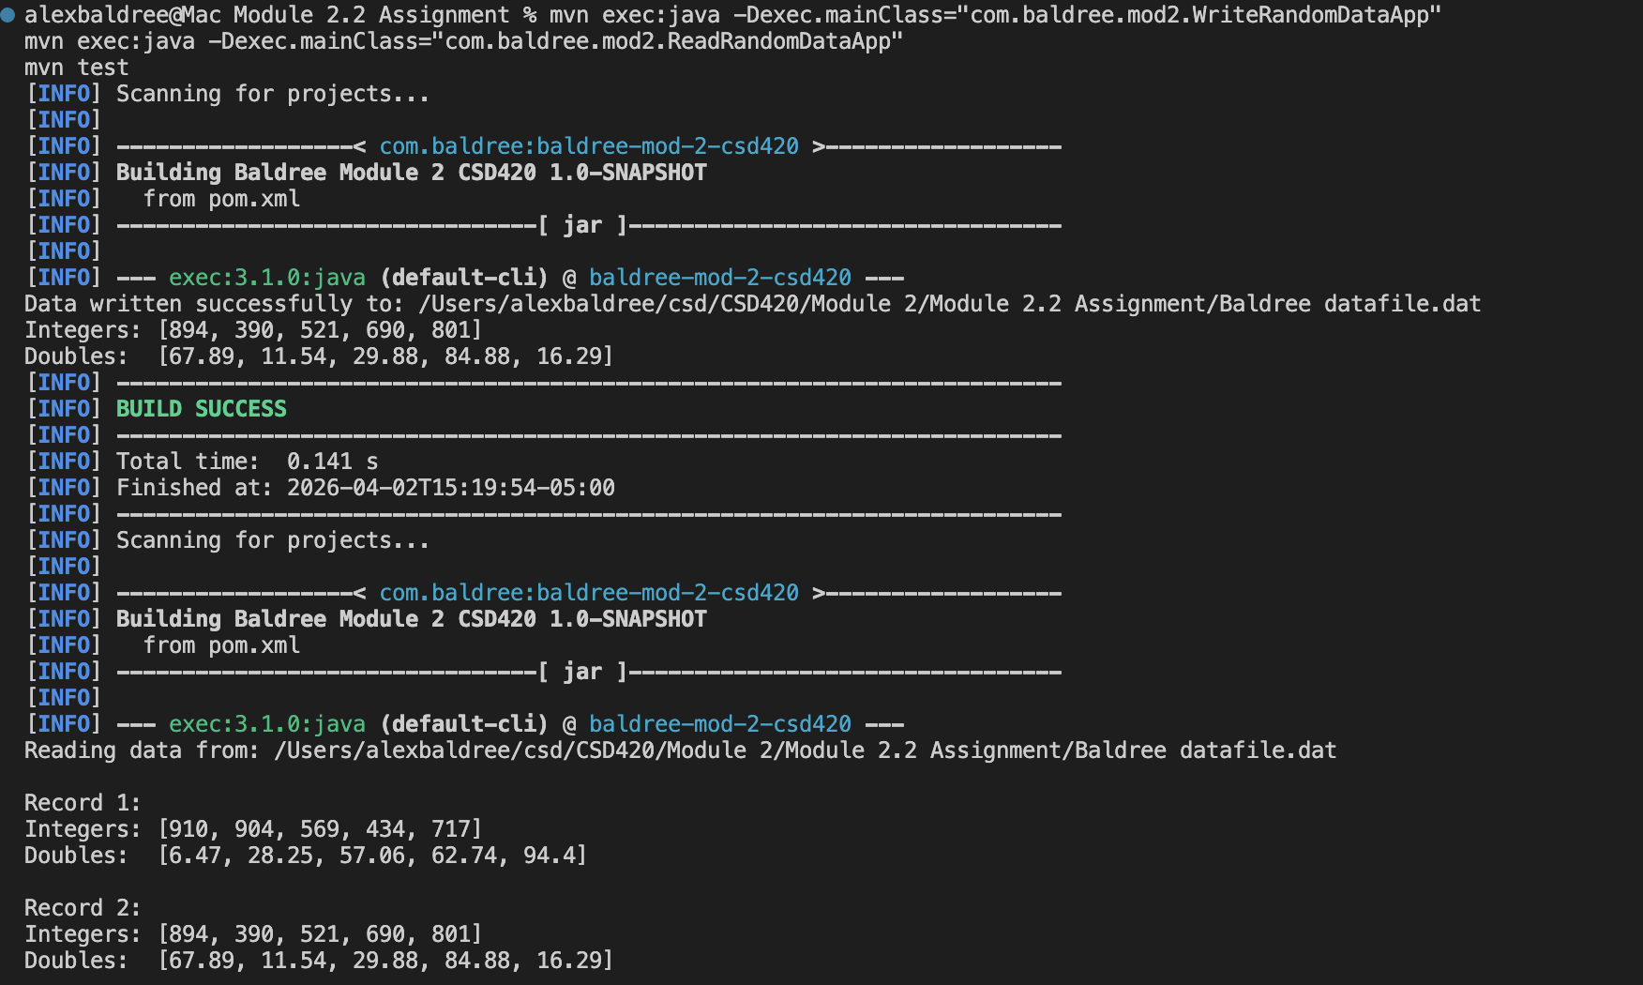
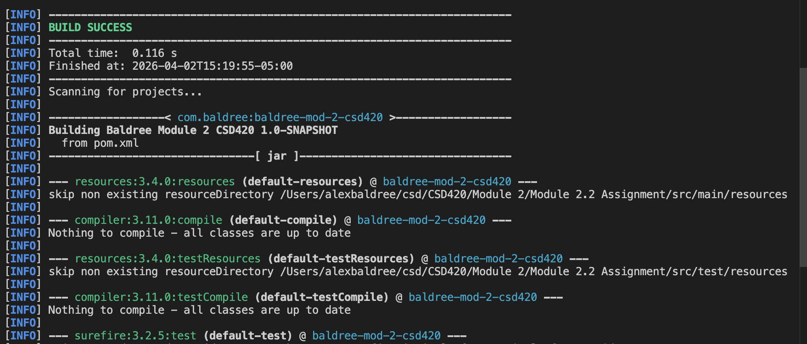
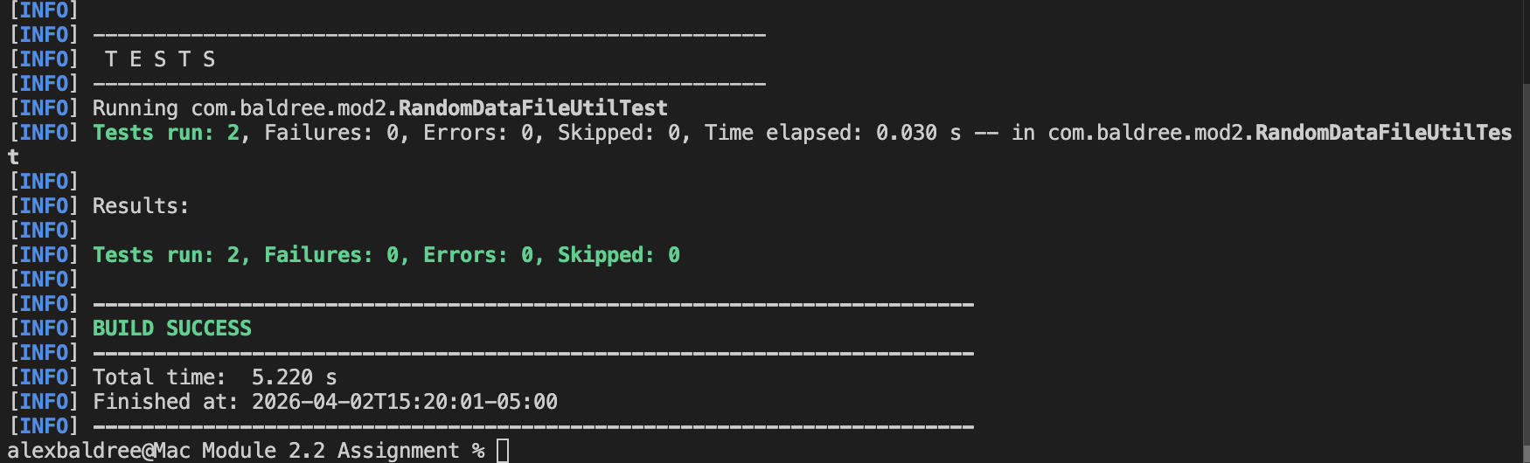

Maven Library:
